**Graduate Programming Project**

**Ace Insurance**

**By:**

**Swapnil Salvi (802968172)**

**CPSC 473**

**Professor: Kenytt Avery**



**Department of Computer Science**

**California State University, Fullerton**

**Spring 2016**

Contents:

Introduction: 3

Functionalities: 3

Home Page: 3

Login: 4

Sign up: 5

Get Insured: 10

Car: 11

Bike: 16

Life: 17

Find an agent: 20

Technologies used: 21

# Introduction:

The project is an insurance company website where the users just have to sign up on the website and they can browse through various categories the website has to offer and once they have checked the price they can purchase the insurance from the website. The website also offers another functionalities such as email updates and meeting with an agent.

# Functionalities:

## Home Page:

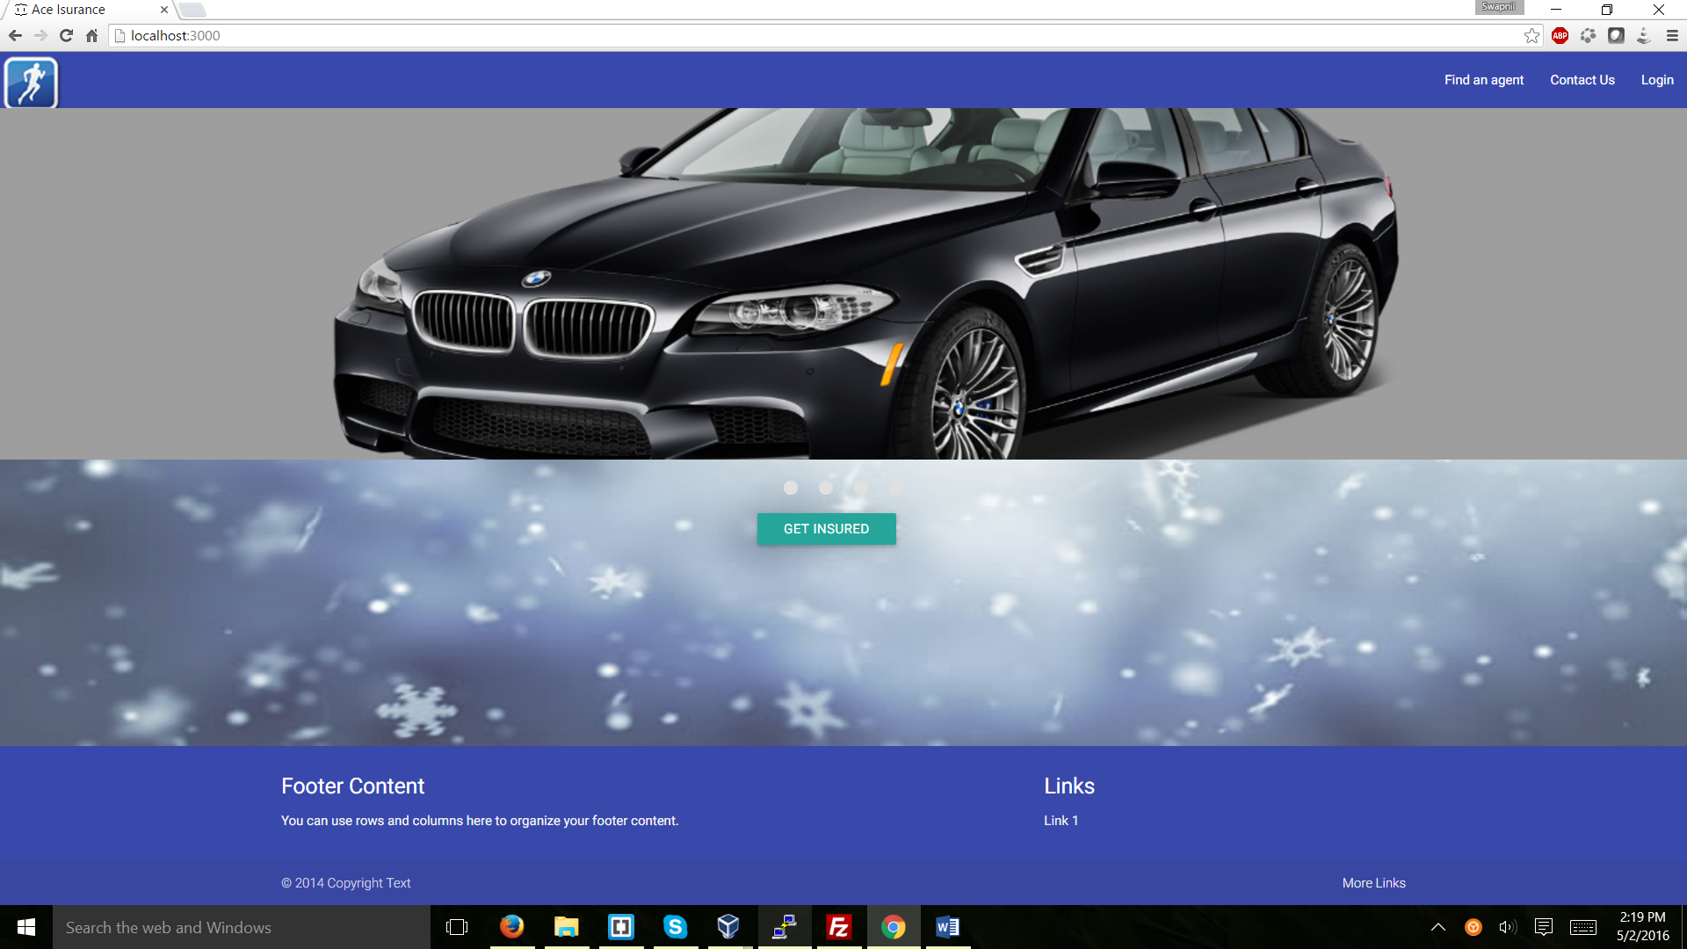

Figure 1: Home Page

## Login:

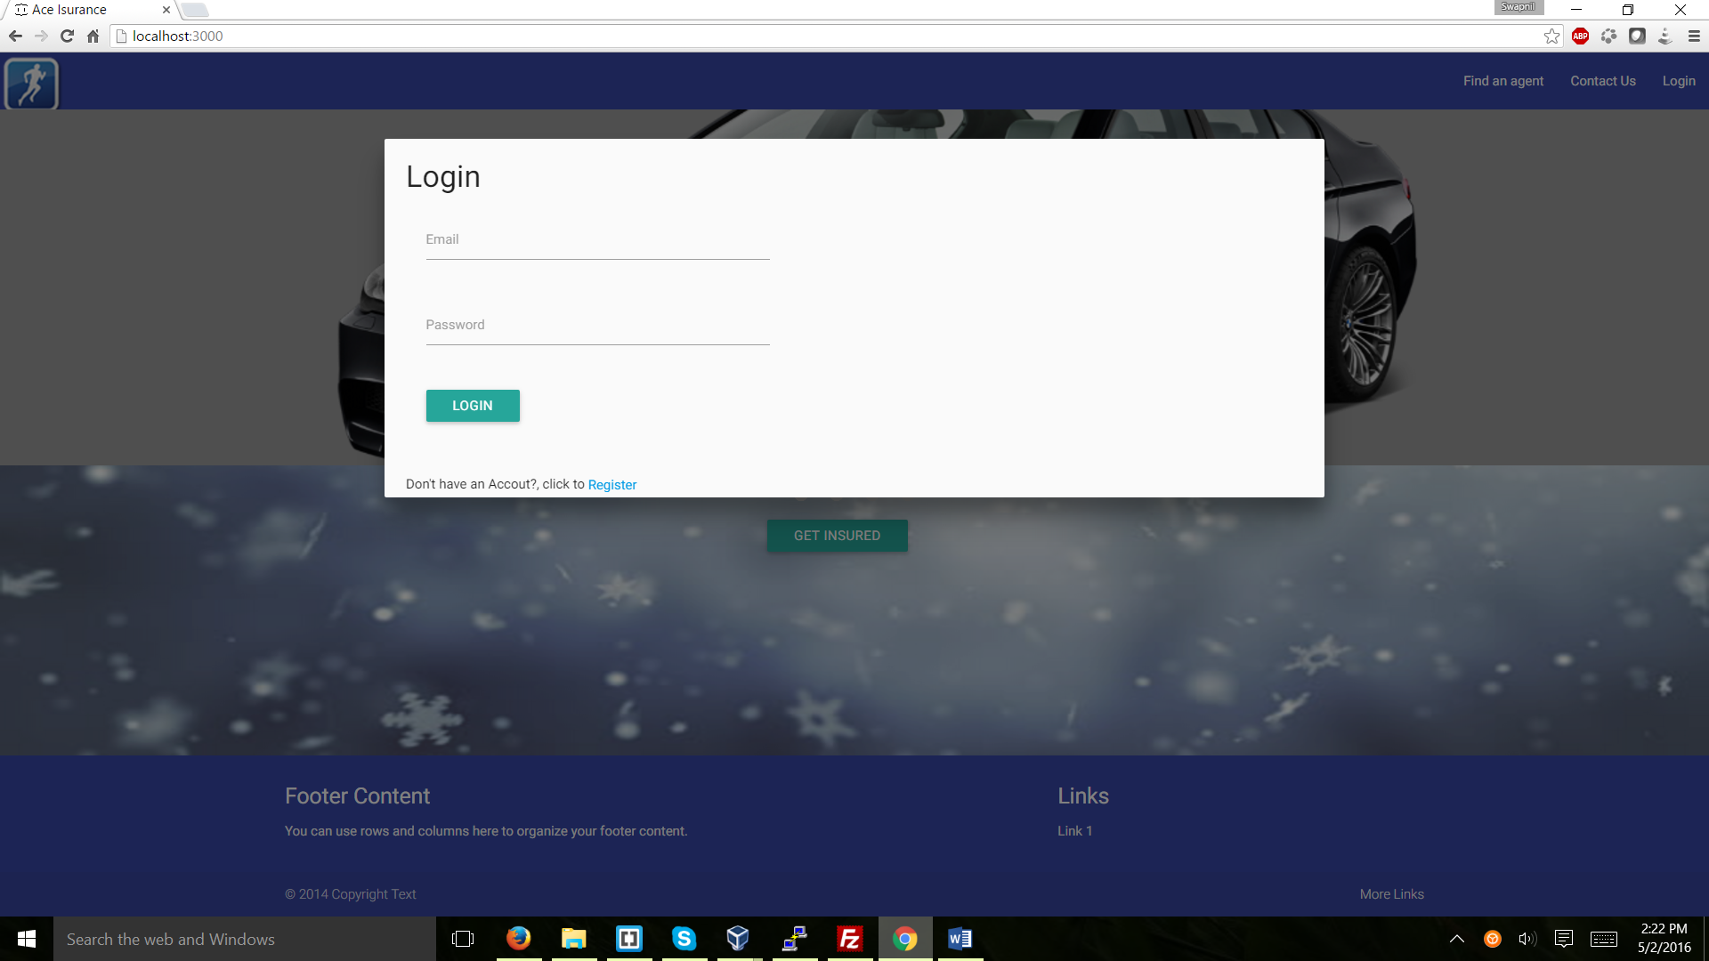

Figure 2: Login

## Sign up:

The user has to register first in order to login to the portal

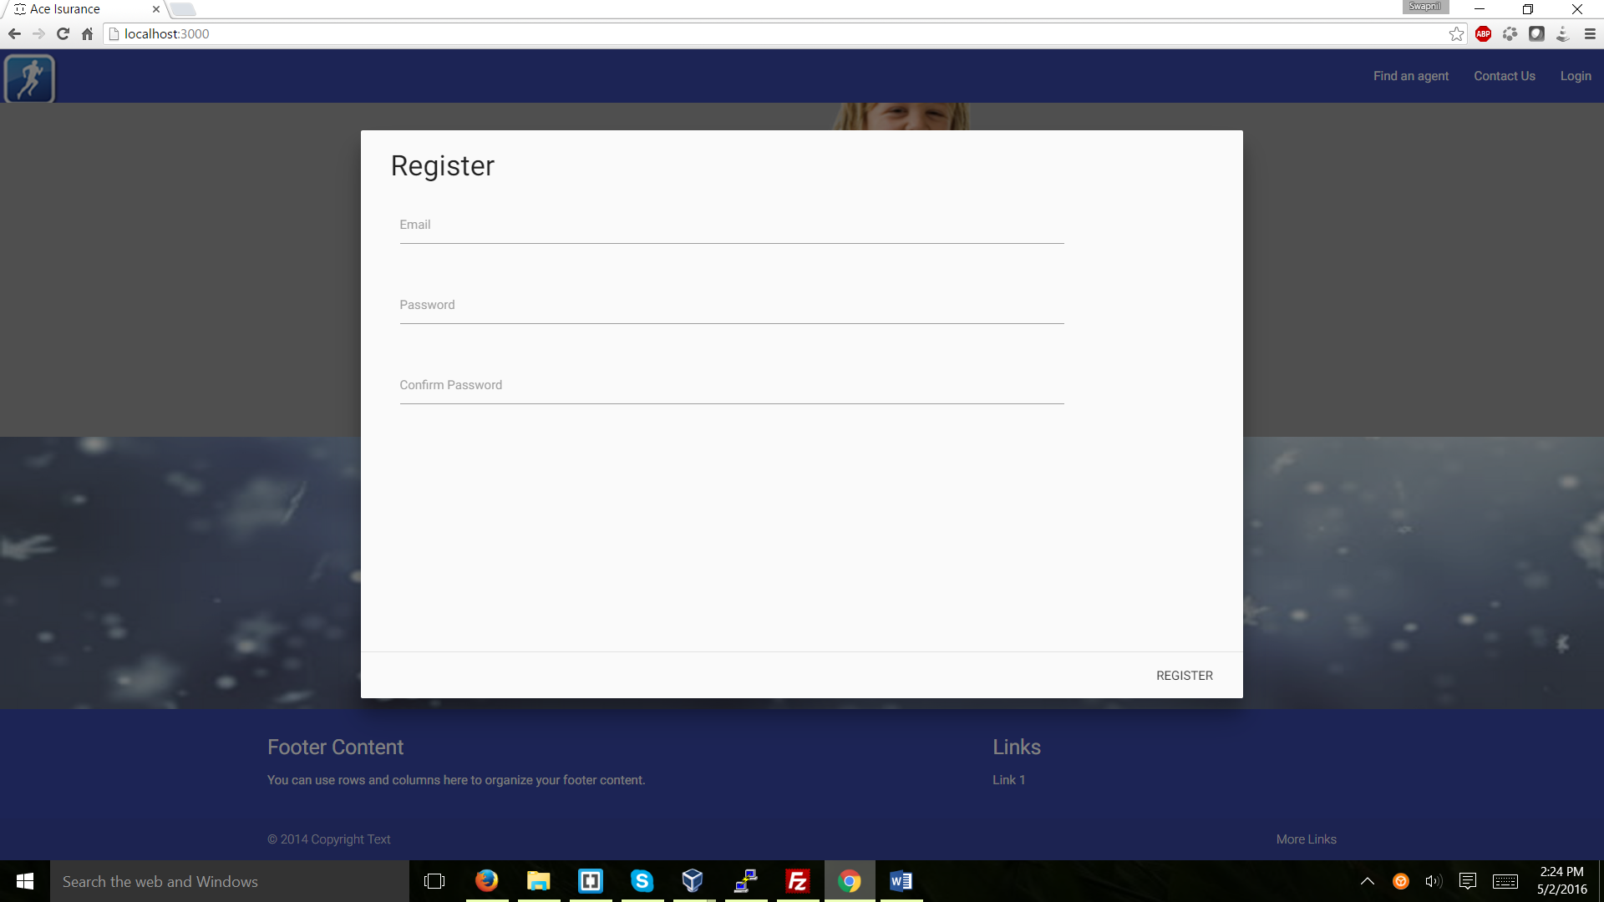

Figure 3.1: Signup

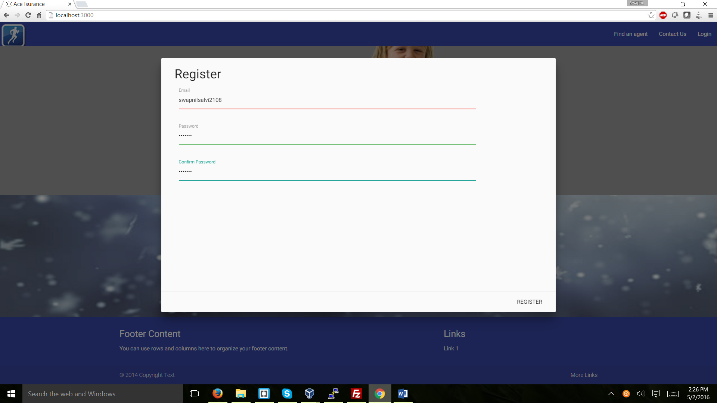

Figure 3.2: Email validation

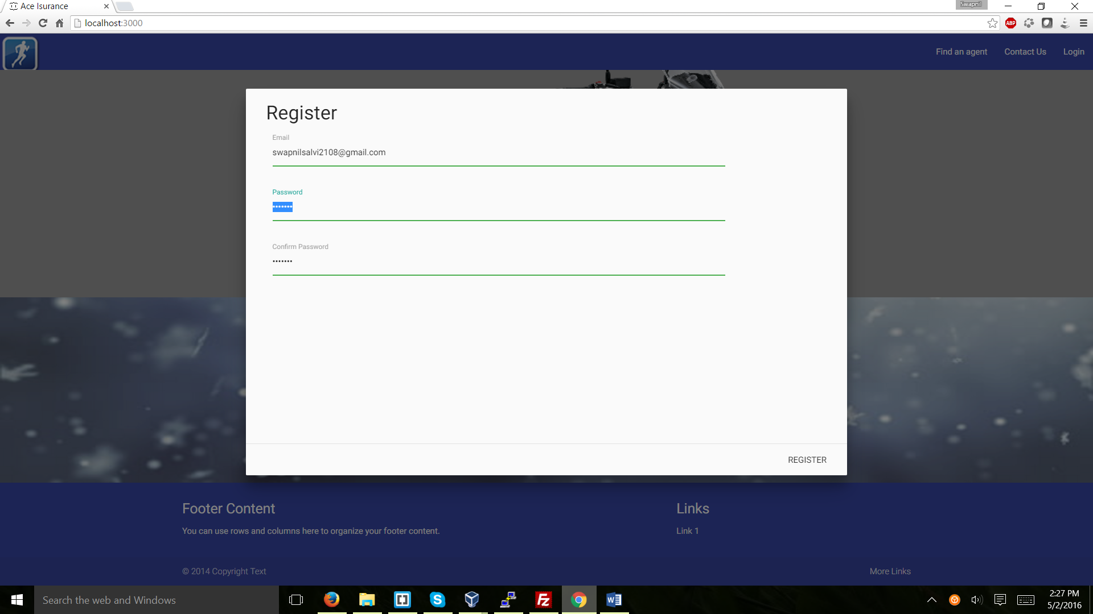

Figure 3.3: email is correct

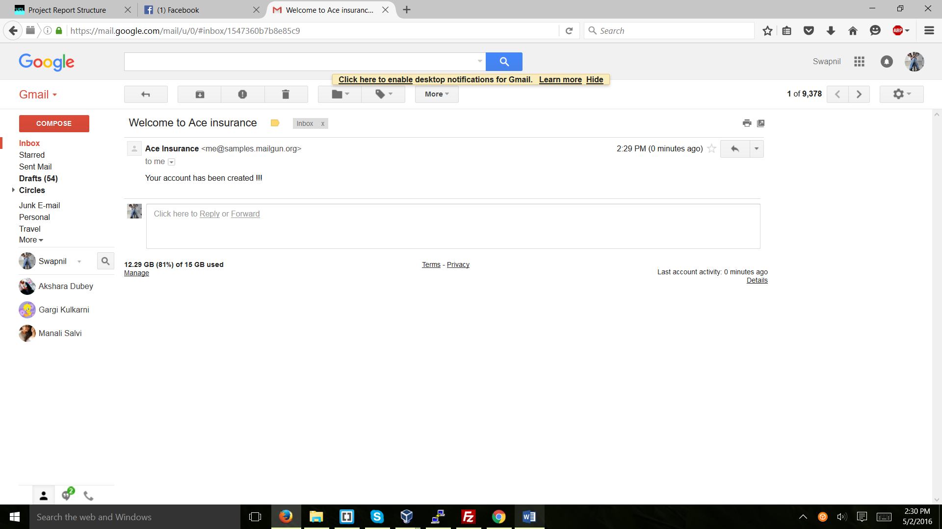

Figure 3.4: Email after registering

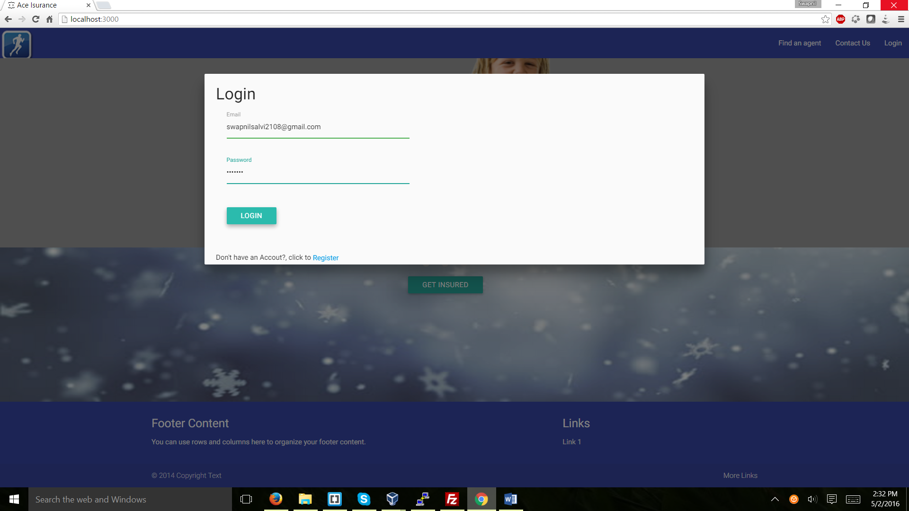

Figure 3.5: Login

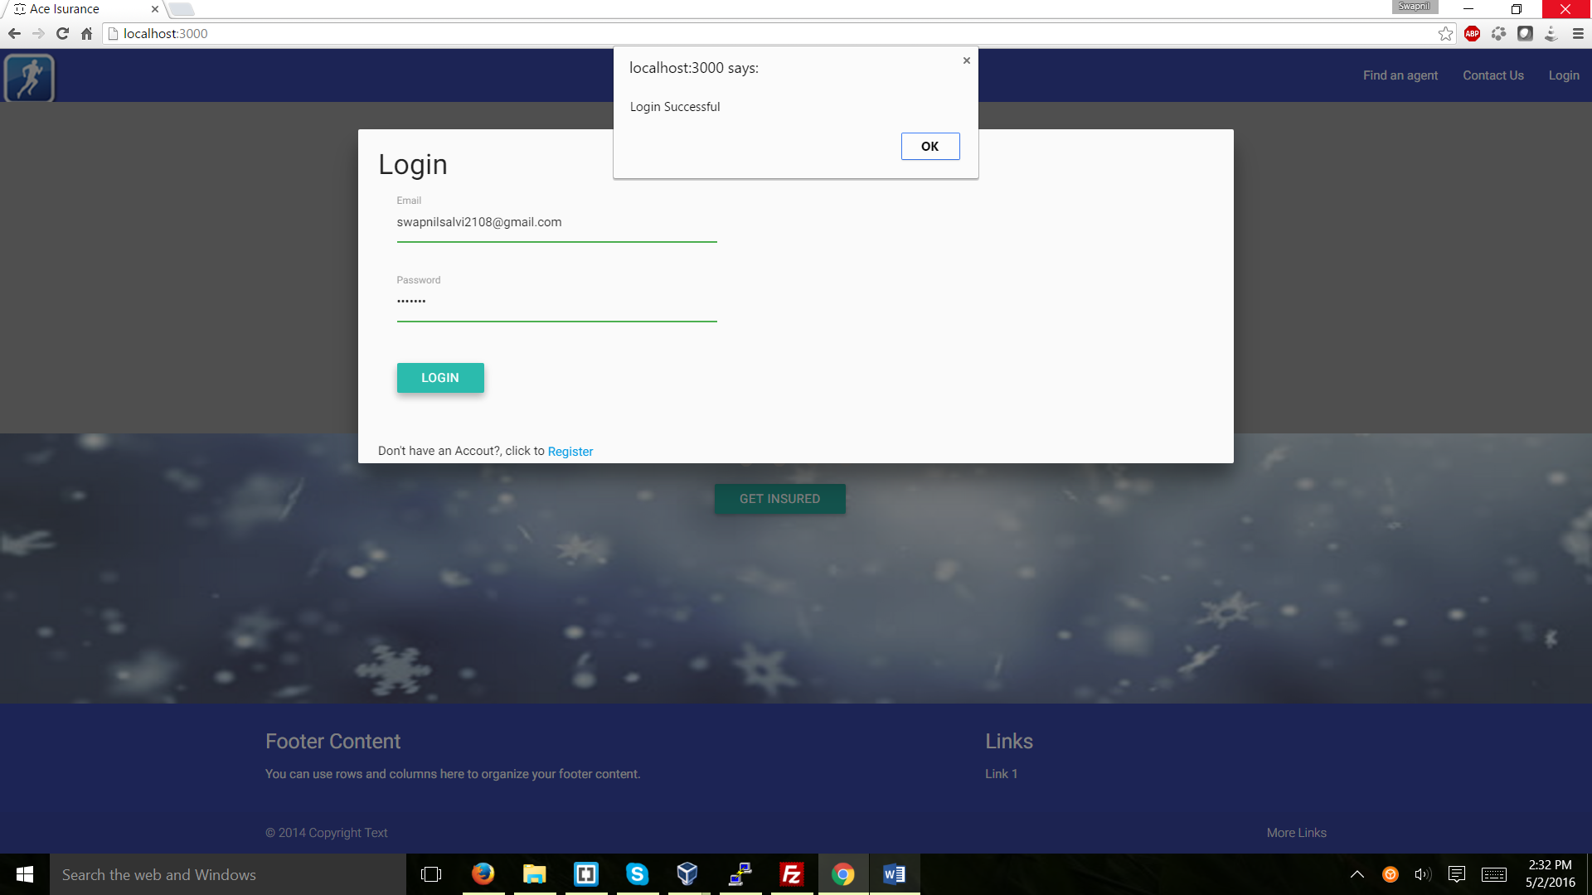

Figure 3.6: Successful login

## Get Insured:

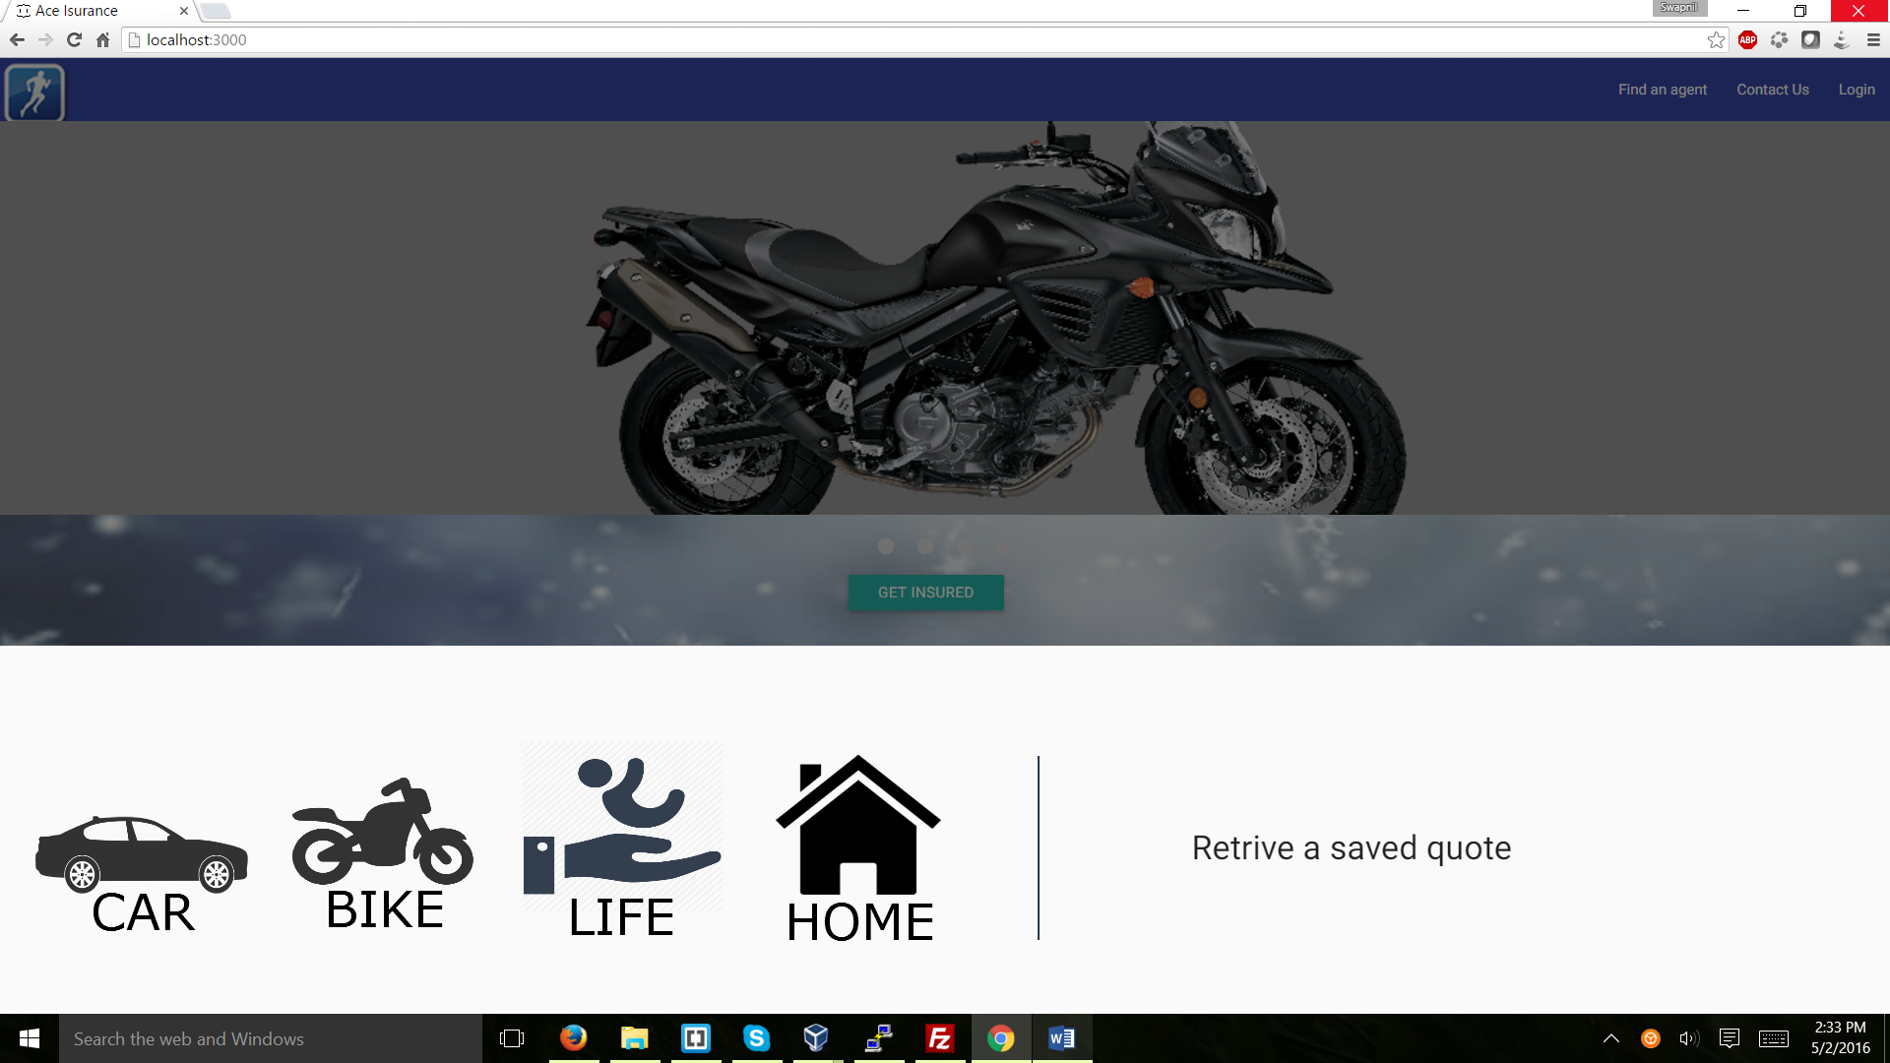

Figure 4: get insured button activates a modal

## Car:

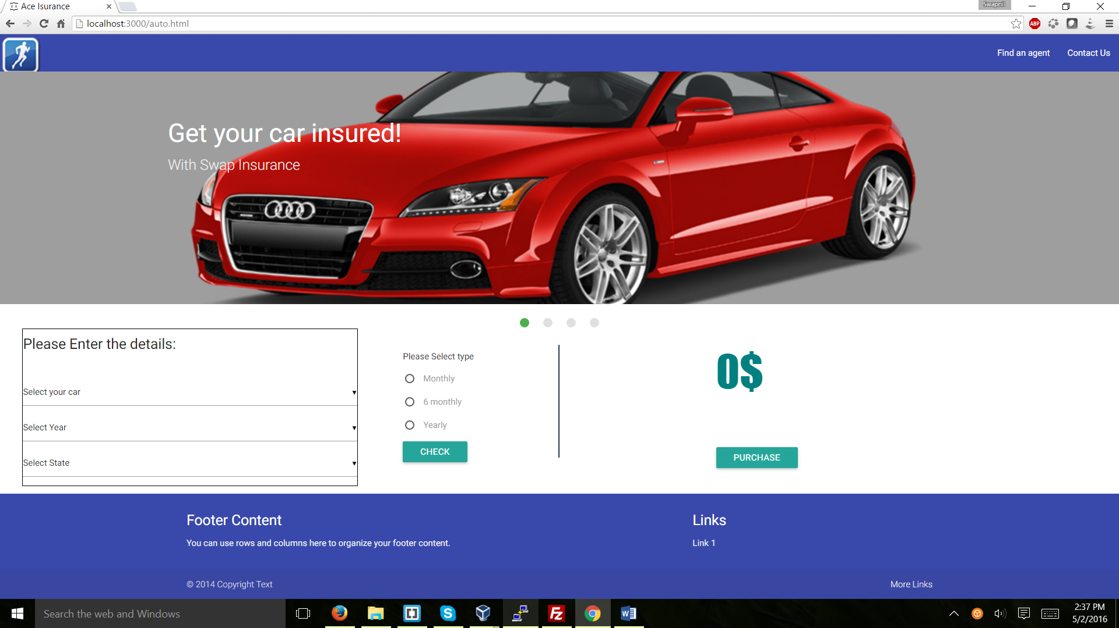

Figure 5: Car Insurance home page

The user has to enter the details of the car and the price which is shown on the right hand side of the page gets updated accordingly.

Select Car:

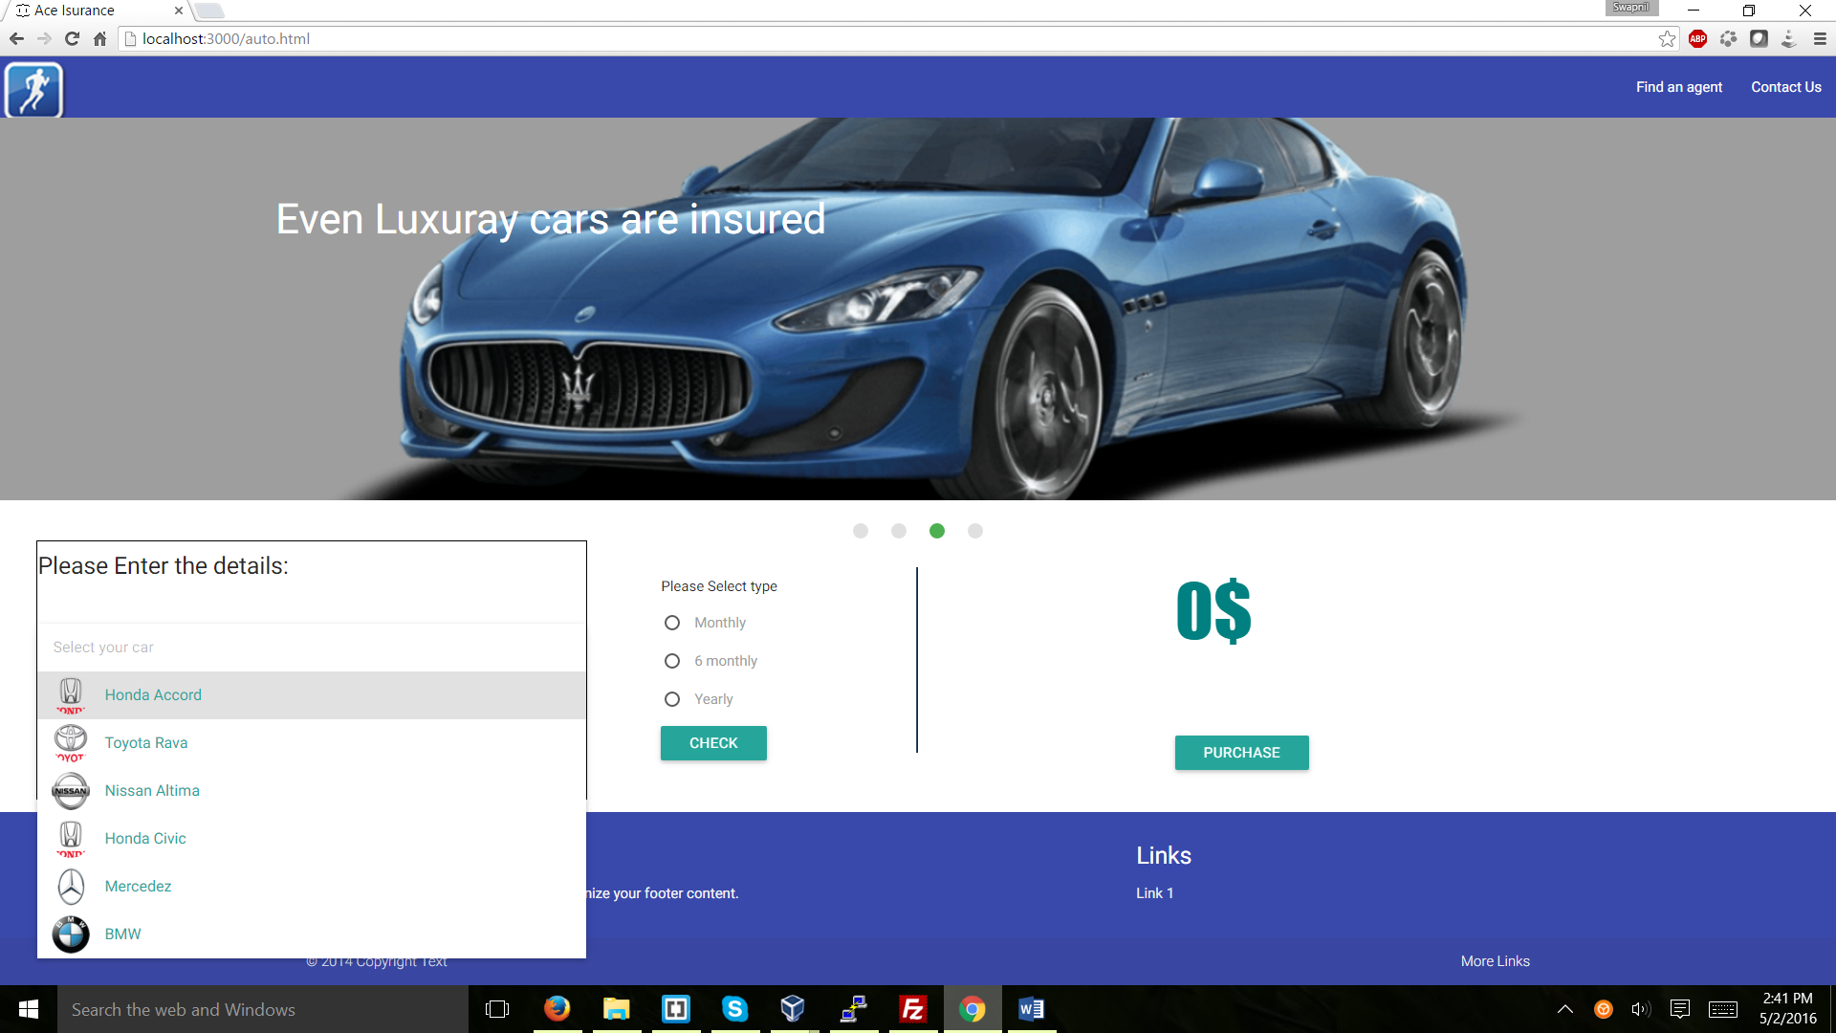

Select Year:

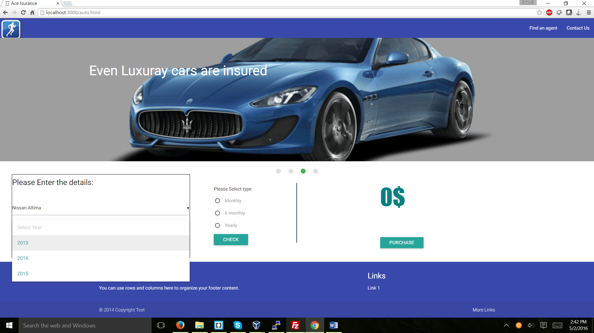

Select State:

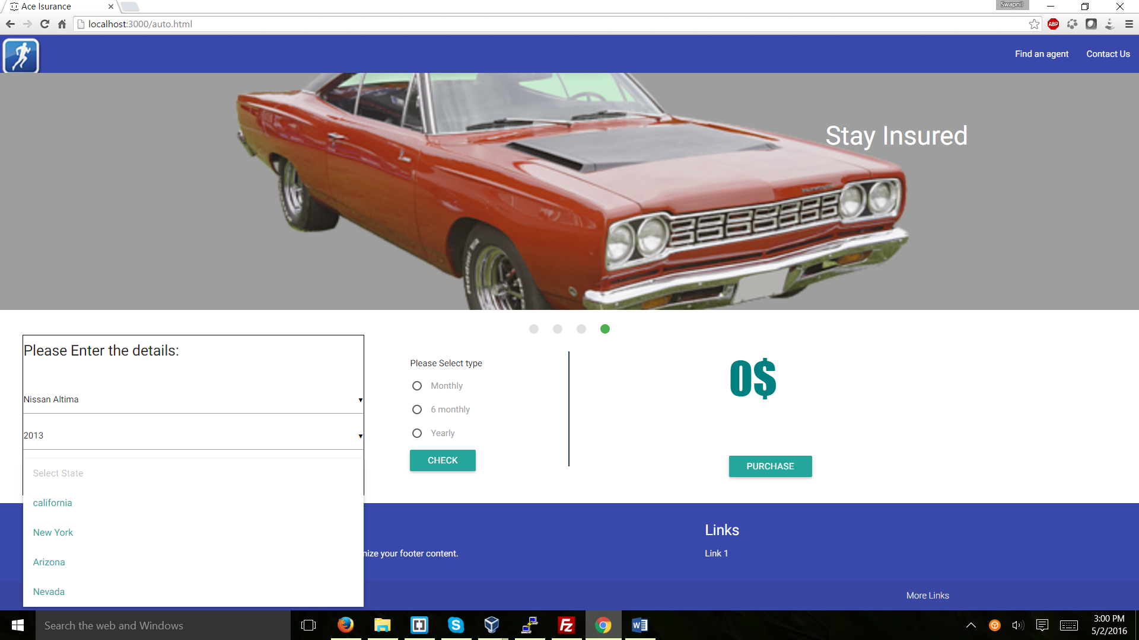

Select Type and check:

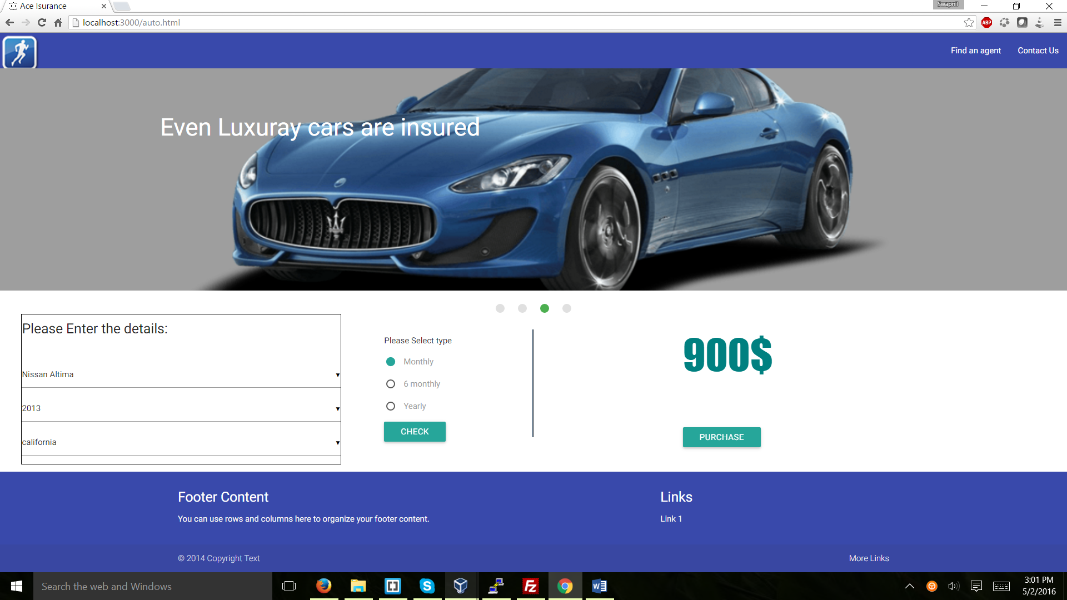

Six monthly

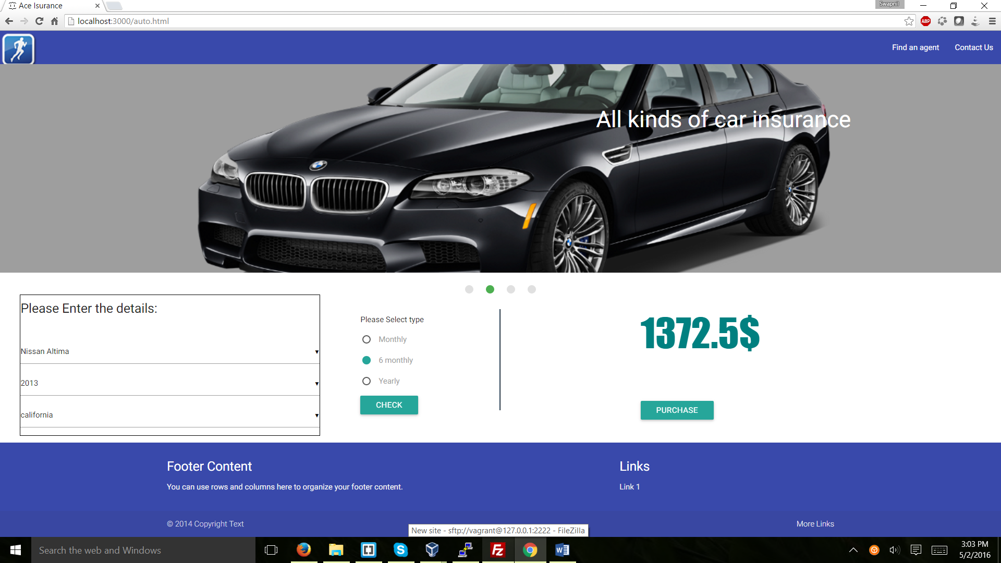

Purchase:

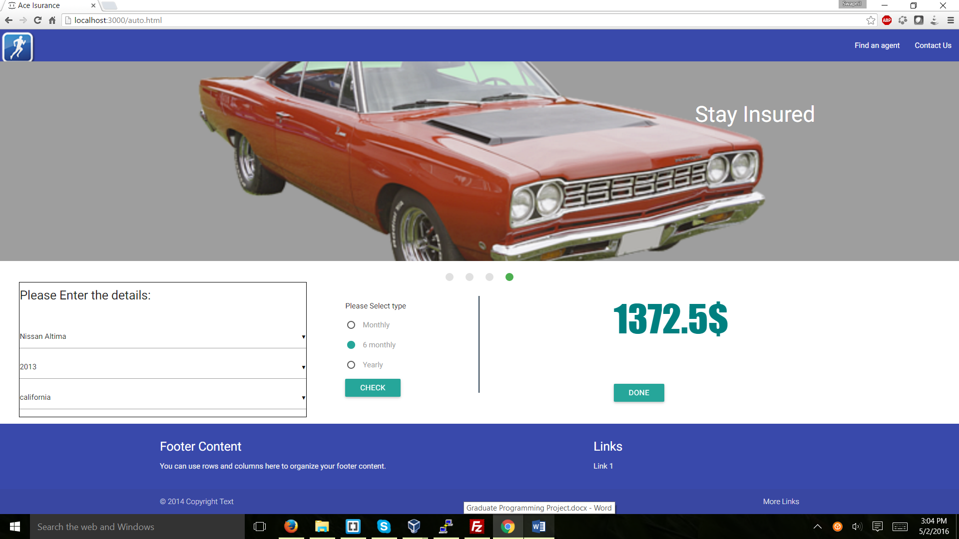

Email Notification after Purchase:

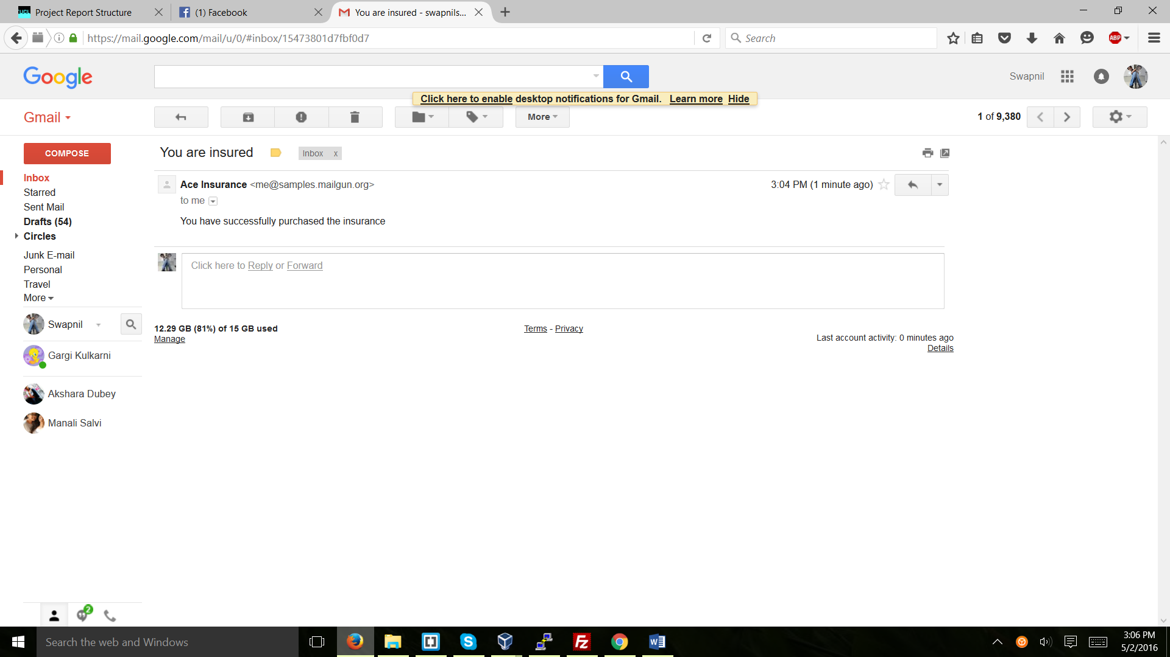

## Bike:

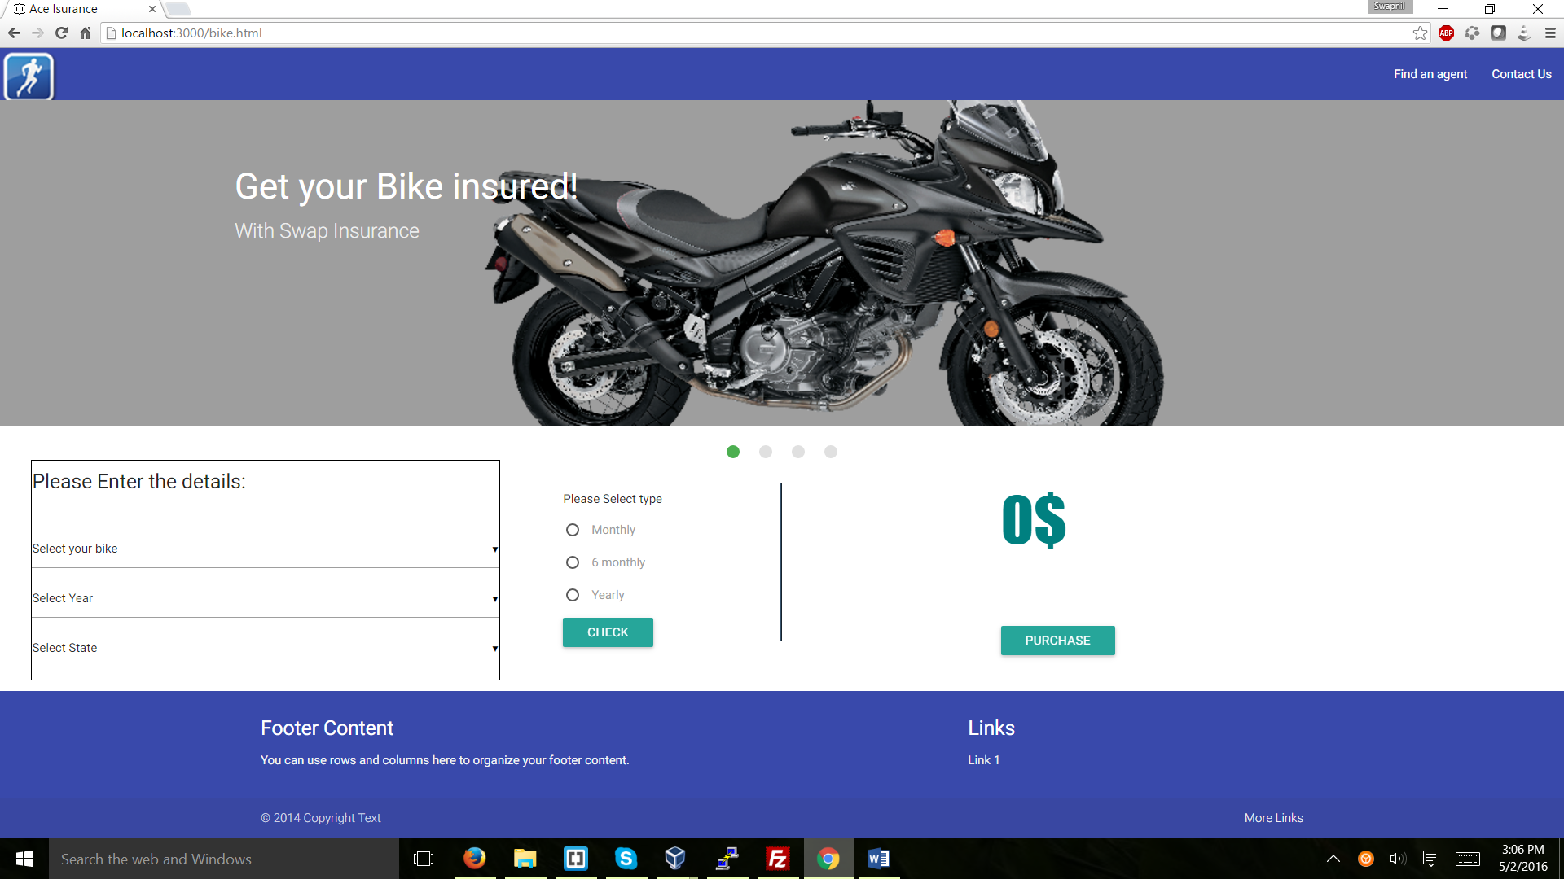

The same process is carried out with the bike insurance

## Life:

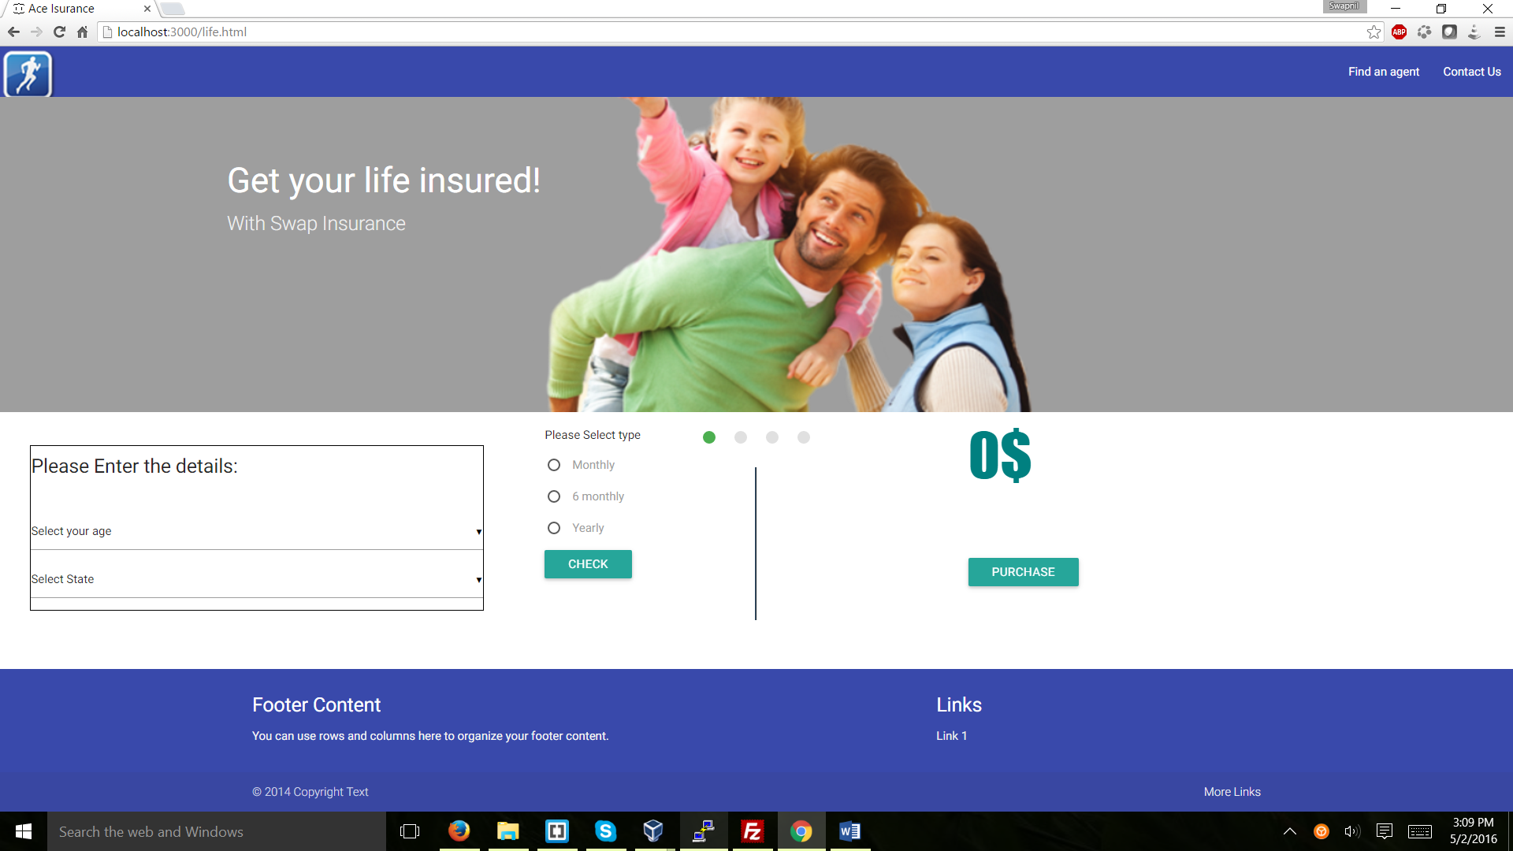

The details such as age and state are taken and the quote is calculated:

Select Age:

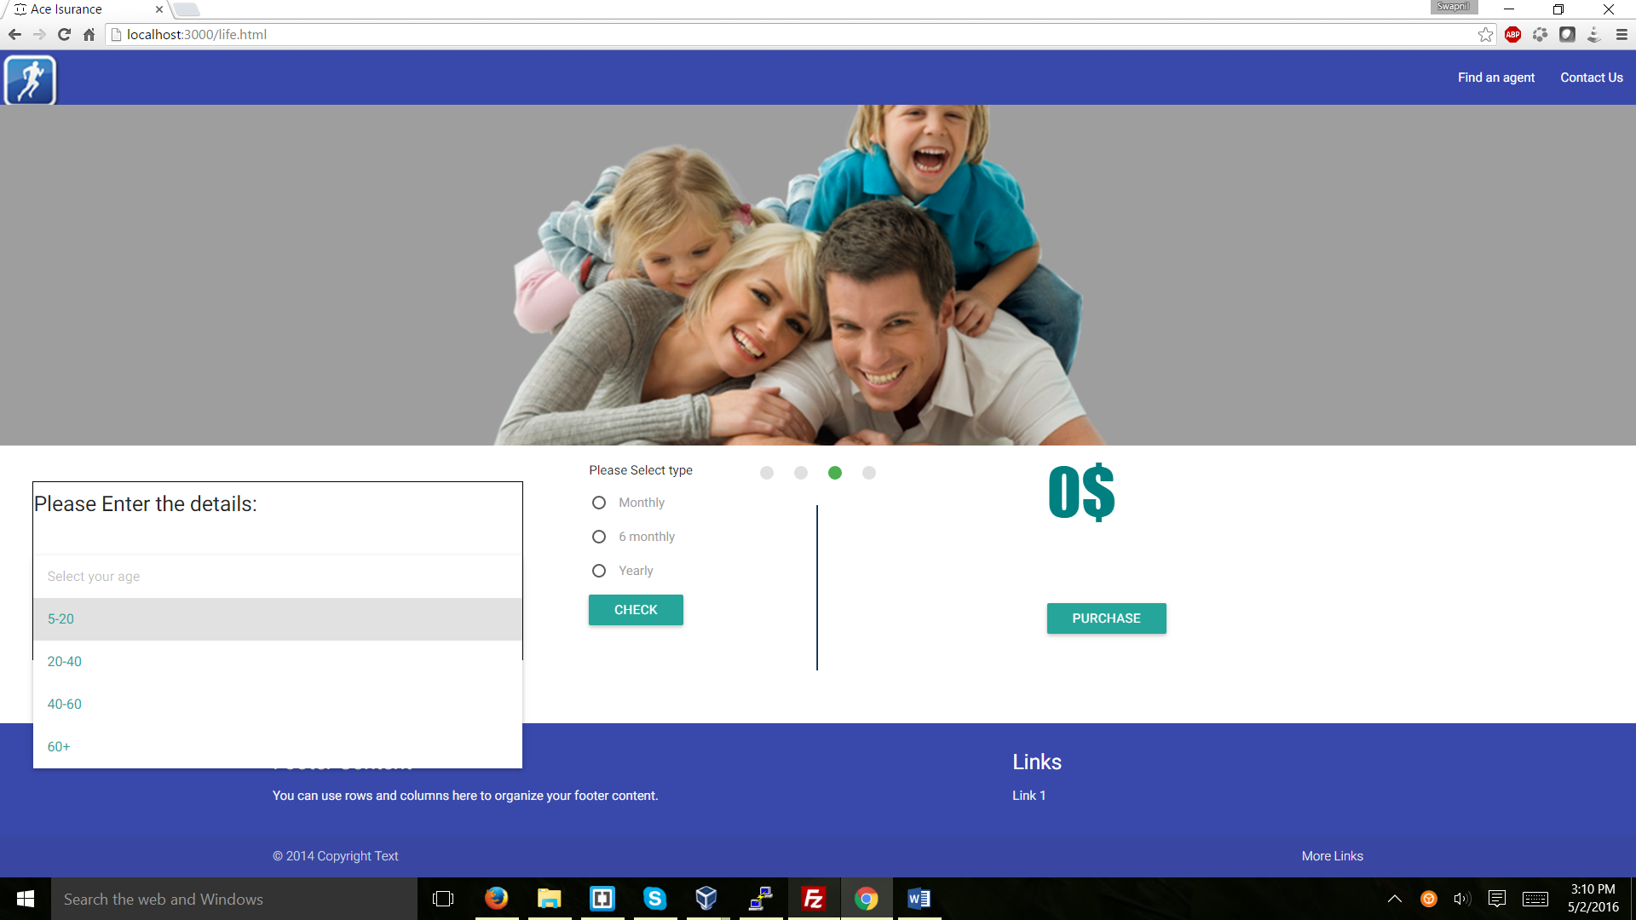

Select State:

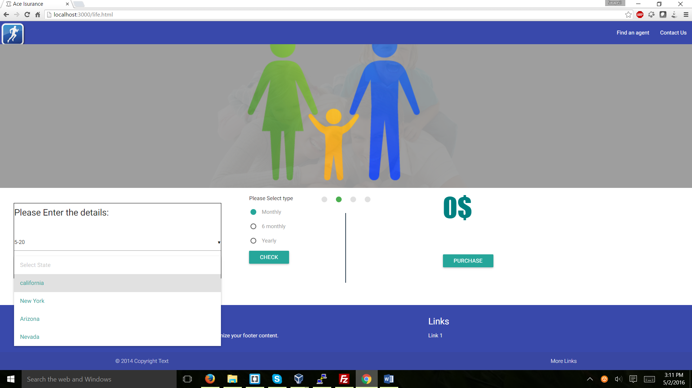

Check:

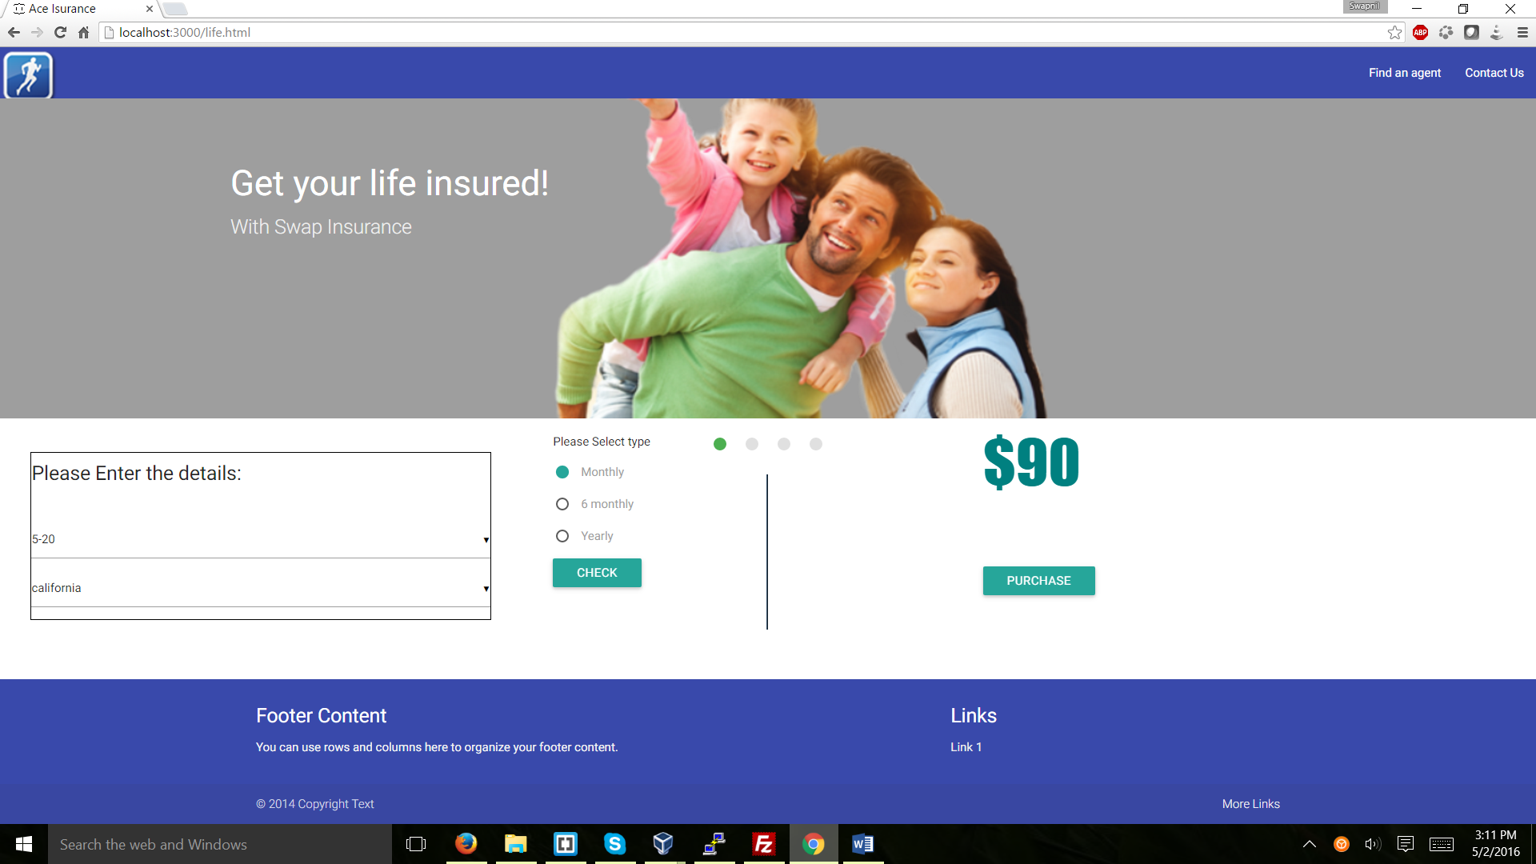

Purchase:

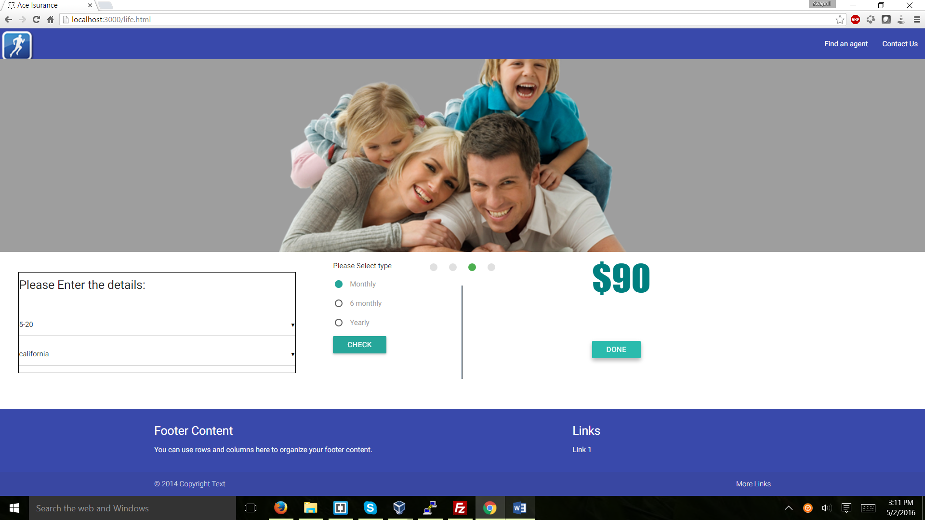

Email Notification:

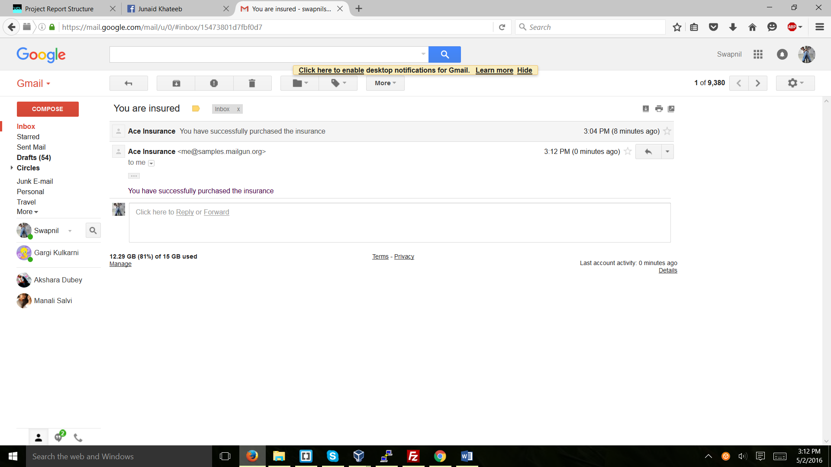

## Find an agent:

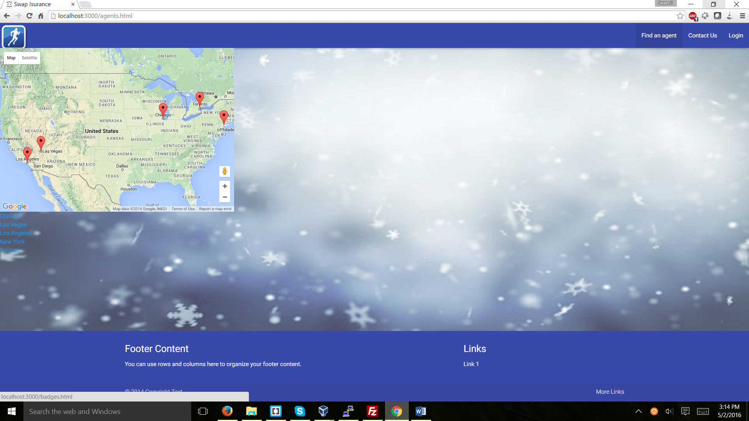

Tried to use google maps api for showing the agents nearby using markers but couldn’t complete the thing.

# Technologies used:

1. HTML

To structure the website.

1. CSS(Materialize)

For styling.

1. Angular.js

For the functionalities of the project and for communicating with the server

1. Jquery

To add functionalities to the CSS.

1. MongoDb

For saving the users data

1. Node.js

For creating the server

1. Express

For the routes to the server

1. Node mailer

For sending email notifications to the users